STUDENT DETAILS
NAME: VALENTINE NUDI ODHIAMBO
ADMISSION NUMBER: BSCCS/2025/52984
COURSE: COMPUTER SCIENCE
UNIT CODE: BIT3208
UNIT NAME: ADVANCED WEB DESIGN AND DEVELOPMENT
LECTURER: MICHAEL NYORO
SEMESTER: 2.1

PROJECT DETAILS
PROJECT TITLE: HOSPITAL SYSTEM
SELECTED TECHNOLOGIES: HTML, CSS, JavaScript, PHP, MySQL, XAMPP, VS Code.
GITHUB LINK: https://github.com/Nudivalentine/BIT3208_Hospital_System_Project

Table of Contents
Week 1: Local Environment Setup 4
Title 4
Installation and Testing of Local Development Environment 4
Installation of XAMPP 4
Apache and MySQL Running 5
Localhost Test Page 5
Hello world Test 6
Database Connection Test 6
Student Reflection 6
Week 2: Wireframes and GUI Design 7
Title 7
User Interface Planning and System Design 7
Hand-drawn Wireframe 7
Dashboard Layout Design 9
Mobile View Mockup 9
Color Theme and Structure 10
GUI Prototype in Figma/Canva/Draw.io 10
Student Reflection 11
Week 3: JavaScript and PHP Basics 11
Title 11
Frontend Interaction and Backend Foundations 11
JavaScript Form Validation 11
Password Strength Checker 12
PHP Syntax Practice 12
Database Connection Script 13
Dynamic User Input Handling 13
Student Reflection 14
Week 4 14
Login form screenshots 14
Form validation screenshots 15
PHP processing screenshots 15
Folder structure screenshots 16
Database connection screenshots 16
GitHub updates 17
Student Reflection 17
Week 5 18
Database screenshots 18
CRUD operation screenshots 18
Login database integration screenshots 19
SQL query screenshots 19
GitHub updates 20
Student Reflection 20
Week 6 21
Database Intergration screenshots 21
CRUD operation screenshots 21
Week 7: 22
User Authentication screenshots 22
Password Hashing screenshots 22
Week 8:Responsive Web Design and Mobile-First Development 23
Desktop view: 23
Tablet view: 23
Mobile view 24

Week 1: Local Environment Setup

Title

Installation and Testing of Local Development Environment

Installation of XAMPP
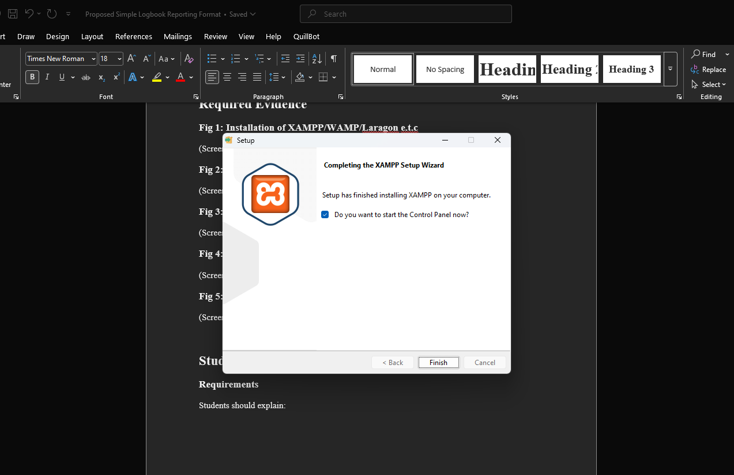
Fig1 shows that the xampp setup is complete. This confirmed that I successfully downloaded and installed xampp.

Apache and MySQL Running
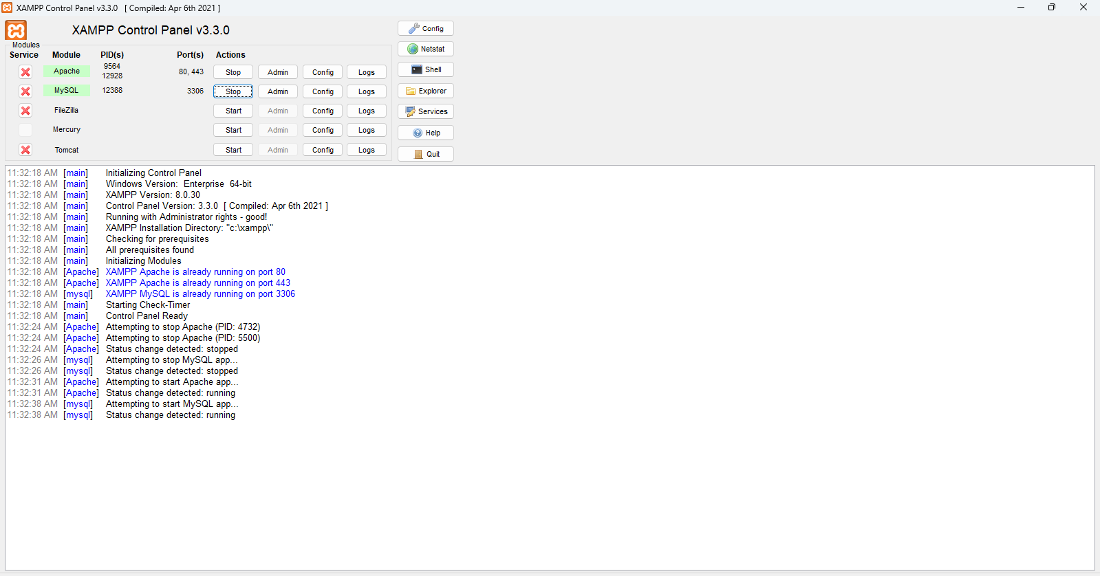
Fig2 shows Apache and MySQL Running successfully without any error using xampp opened as an admin

Localhost Test Page
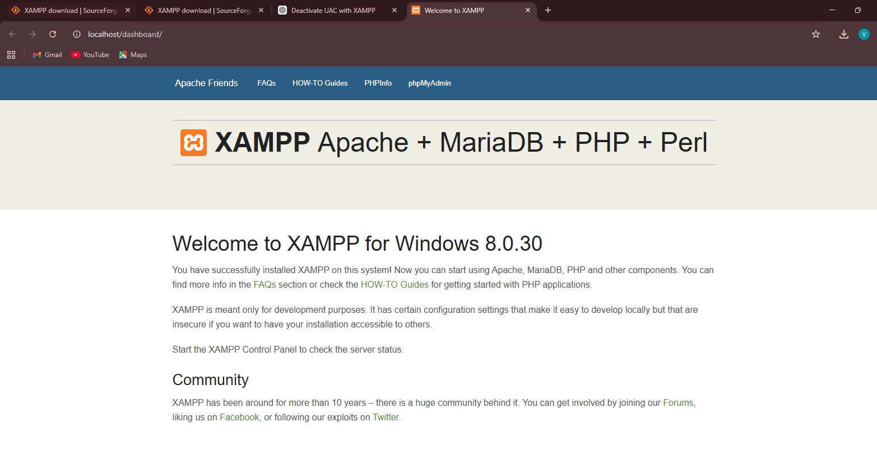
Fig3 shows a screenshot of the localhost test page running which id proof that xampp is fully functional and ready for use.

Hello world Test
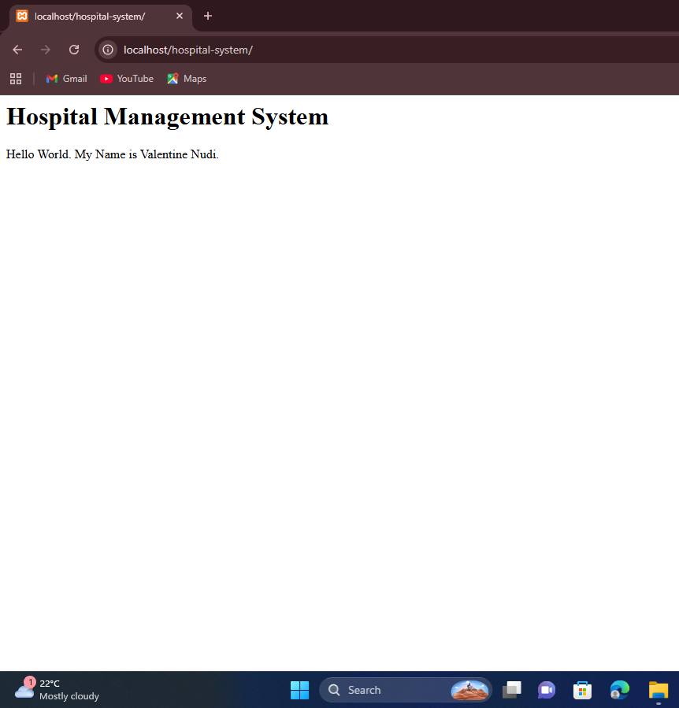
Fig4 shows the screenshot of My first php page

Database Connection Test

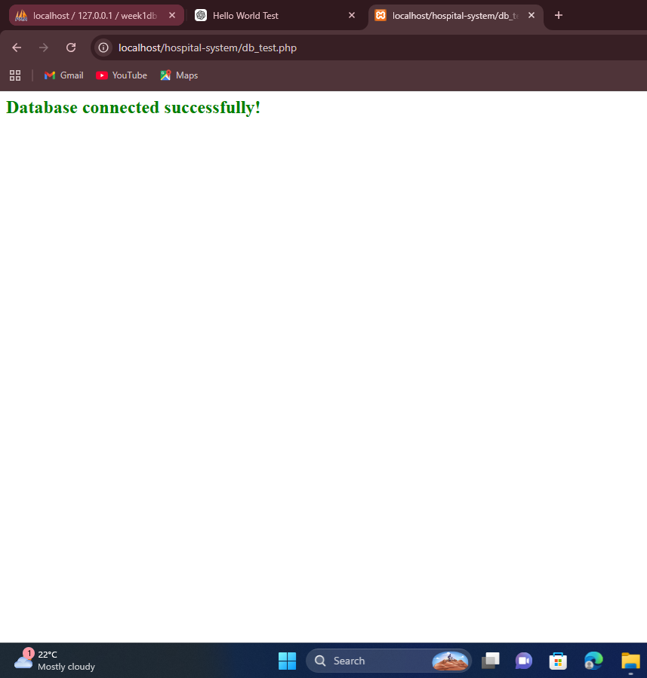

Fig4 shows a screenshot of a successful connection between the database and the frontend. This is after successfully connecting both the database and the frontend

Student Reflection
This task helped me understand how to set up a local development environment using XAMPP and how PHP connects to a MySQL database. I used PHP, HTML, and MySQL to test the basic functionality of the hospital system. One challenge I faced was getting the server and database to run correctly at the same time, as errors occurred when services were not started. Fig 4 demonstrates that the PHP environment is working by displaying output in the browser, while Fig 5 confirms a successful connection between PHP and MySQL using mysqli, showing that the system setup was done correctly.

Week 2: Wireframes and GUI Design

Title

User Interface Planning and System Design

Hand-drawn Wireframe

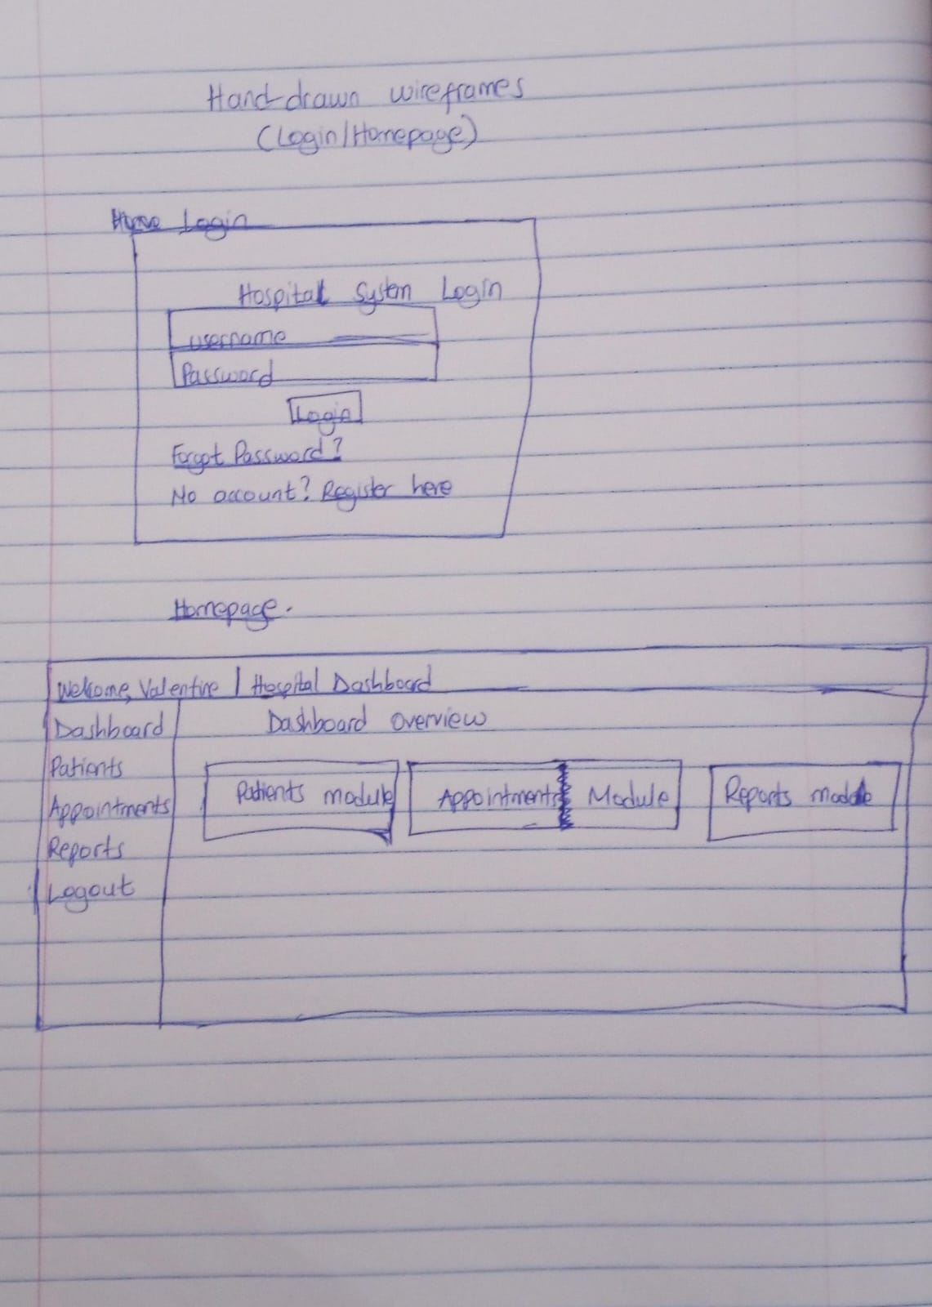
Fig1 shows a handrawn wireframe of the login and homepage layouts drawn as I was bringing the idea to life

Dashboard Layout Design
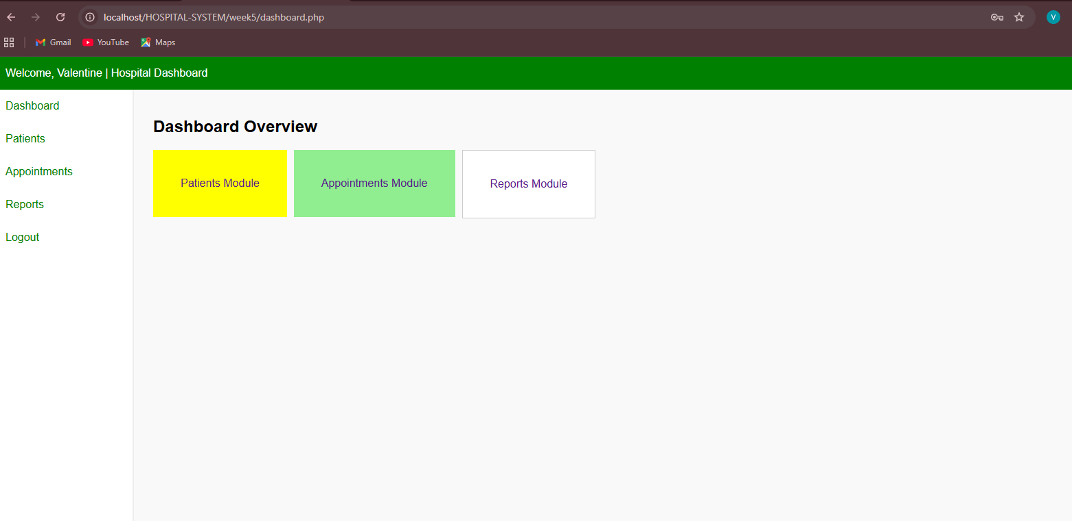
Fig 2 shows the dashboard layout of the hospital system

Mobile View Mockup
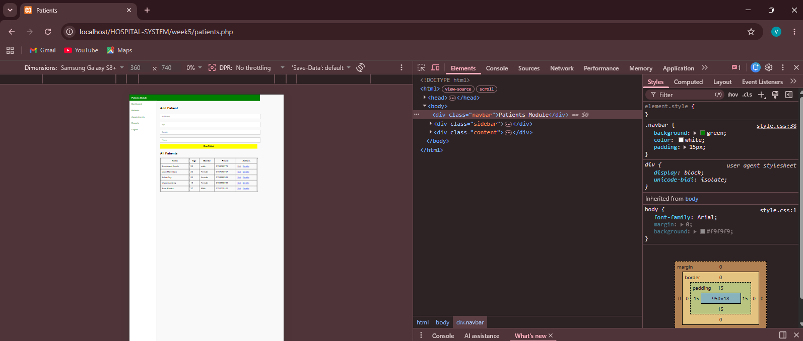
Fig 3 is a screenshot showing that the system is mobile friendly.I used the inspect feature to confirm it using different phone sizes and it is responsive in all of them

Color Theme and Structure

Fig 4 is a screenshot showing the color themes and navigation

GUI Prototype in Figma/Canva/Draw.io
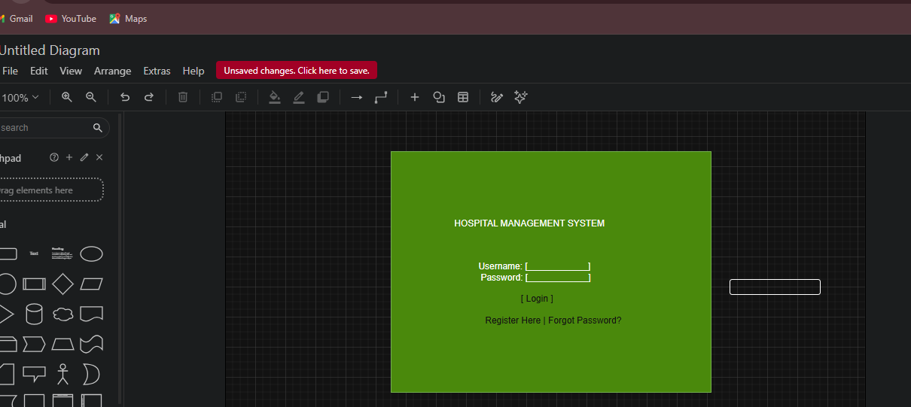
Fig5 is screenshot of the GUI prototype for the login page that I drew using draw.io

Student Reflection
This design was created to make the hospital system simple, clear, and easy to navigate for all users, including staff and administrators. The dashboard layout was selected to reduce the number of clicks needed to access key features like patient records and appointments. The navigation flow was planned in a structured manner, starting from login to the main dashboard and then to individual modules. A consistent color theme was used to improve visual clarity and maintain a professional healthcare feel. The system is mainly designed for hospital staff, receptionists, and administrators to improve efficiency and usability.

Week 3: JavaScript and PHP Basics

Title

Frontend Interaction and Backend Foundations

JavaScript Form Validation
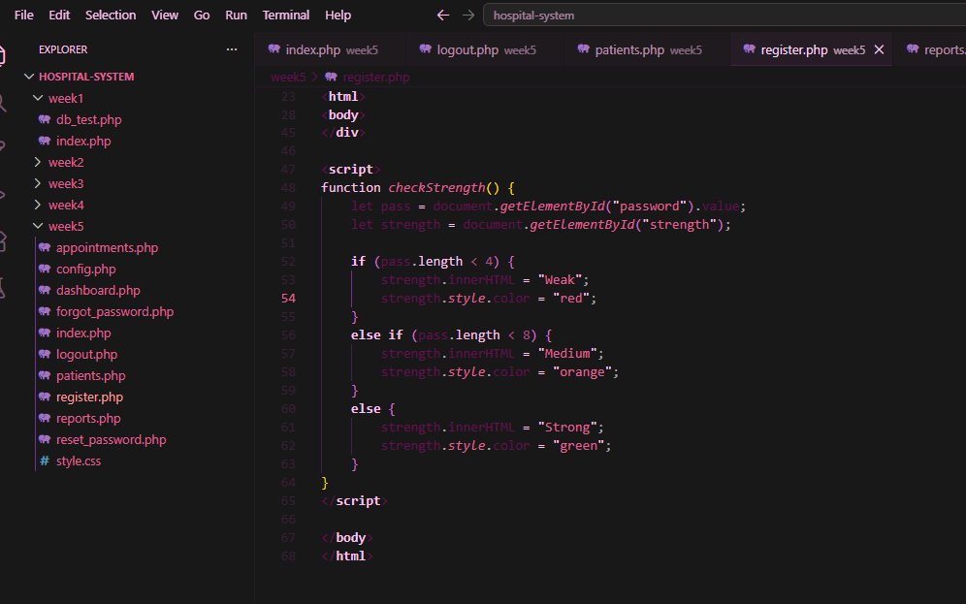
Fig1 above shows the javascript form validation that takes place in the register page

Password Strength Checker
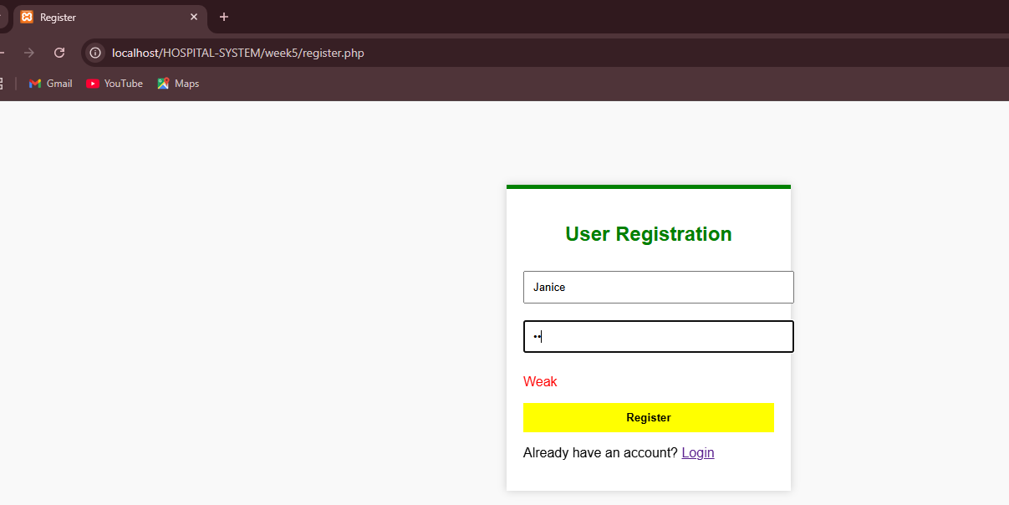
Fig2 shows the screenshot of the Registration page with the password stregnth checker feature

PHP Syntax Practice
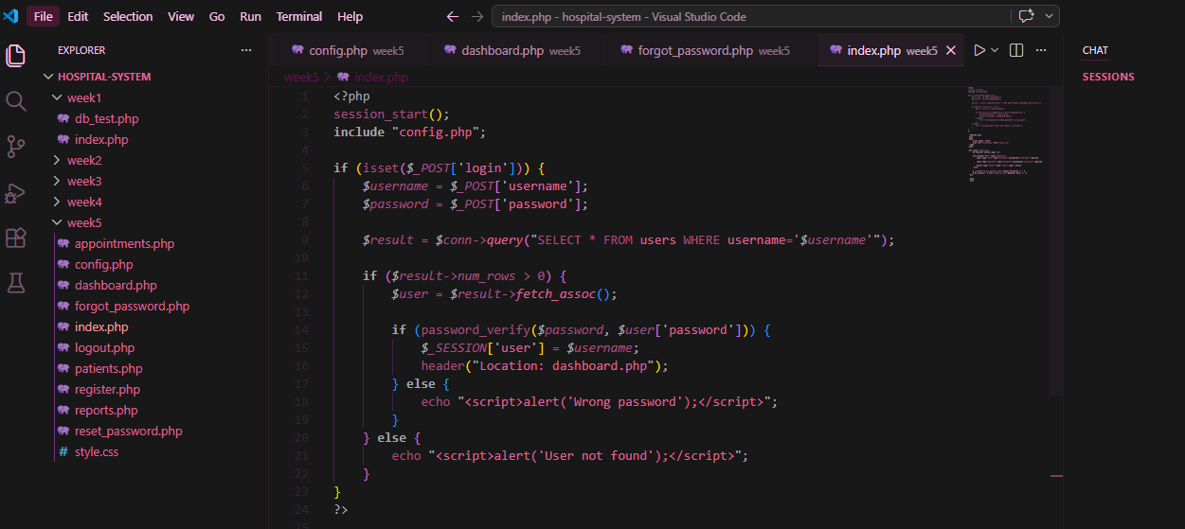
Fig3 shows the screenshot of PHP Syntax. This is a section of the index.php page

Database Connection Script
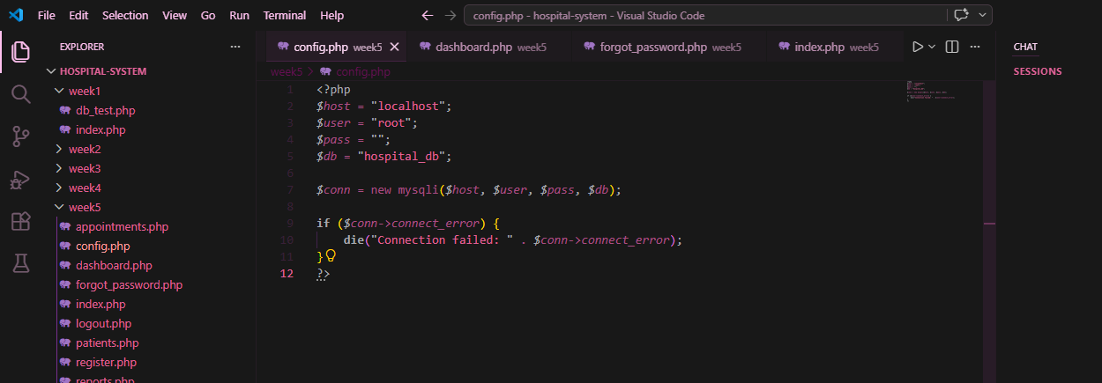
Fig4 shows the screenshot of the database connection script that enables the dynamic user input process

Dynamic User Input Handling

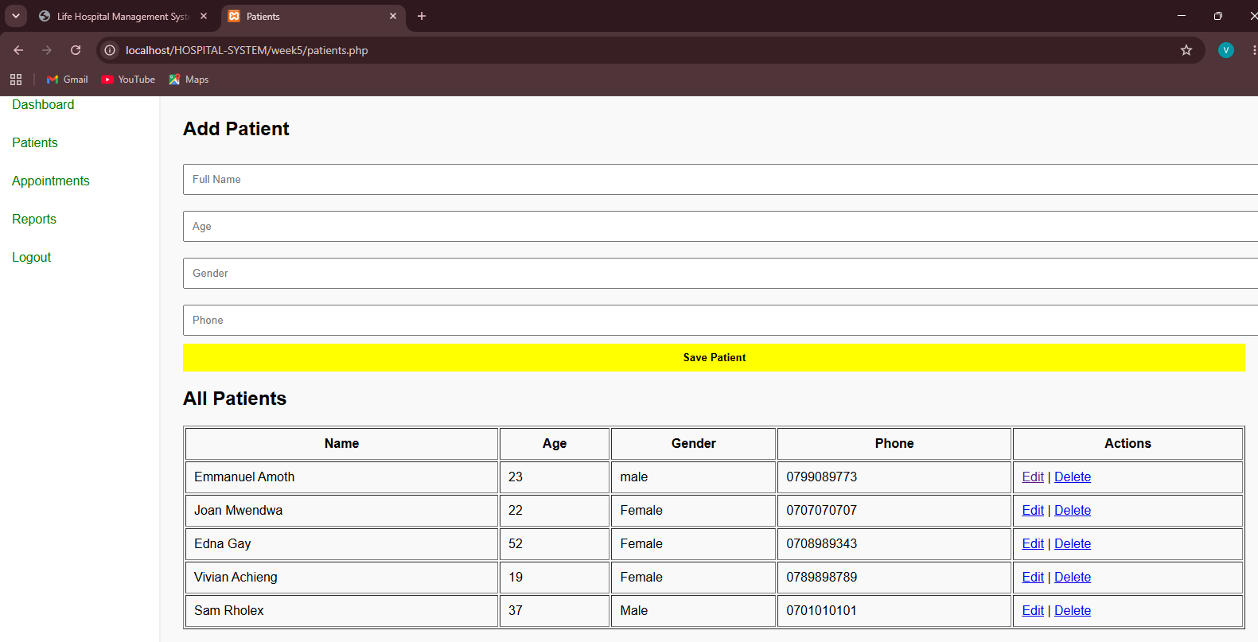
Fig5 shows the screenshot of the dynamic user input handling that is performed by adding data and it autamatically saves or displays records because it is connected to the database part

Student Reflection
This phase helped me understand how the frontend and backend work together to process and manage user data. JavaScript validation was used to check user input before submission, improving data accuracy and user experience. PHP handled server-side processing, including form submissions, authentication, and database operations. The database connection was essential for storing and retrieving information such as users, patients, appointments, and reports. Technologies used included HTML, CSS, JavaScript, PHP, MySQL, XAMPP, and VS Code. These components worked together to create a functional and interactive hospital management system.

Week 4

Login form screenshots
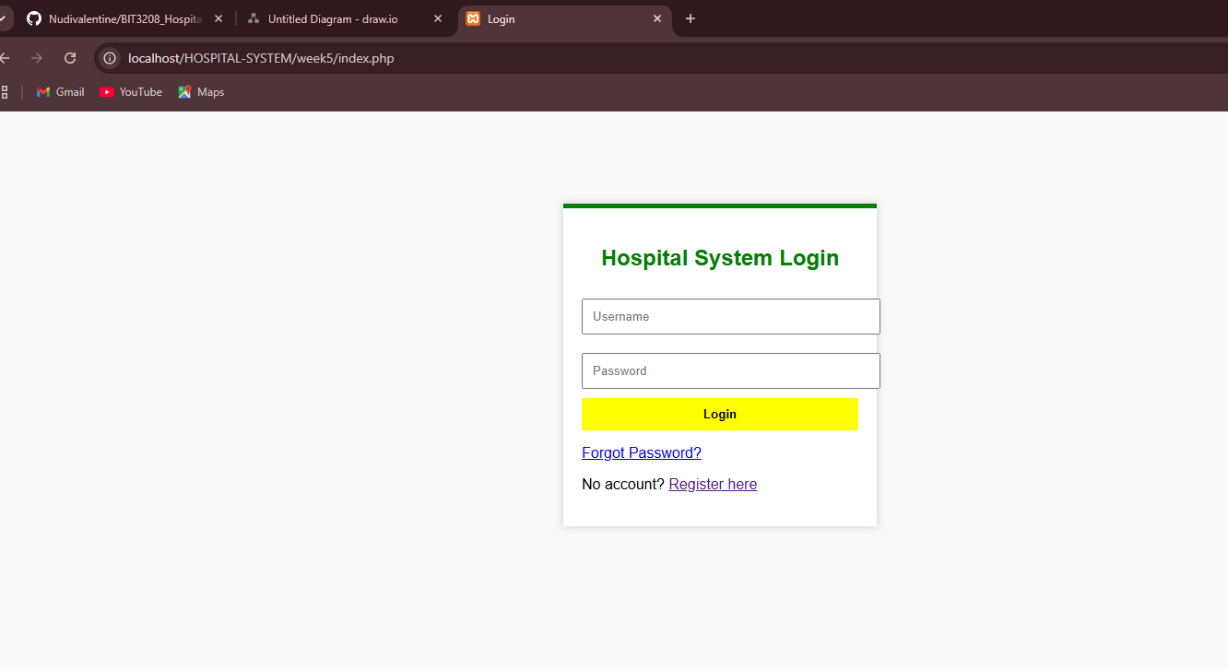
Fig1 shows the screenshot of the system login form that is automatically displayed after a user registers for the first time and the rest of the login times

Form validation screenshots
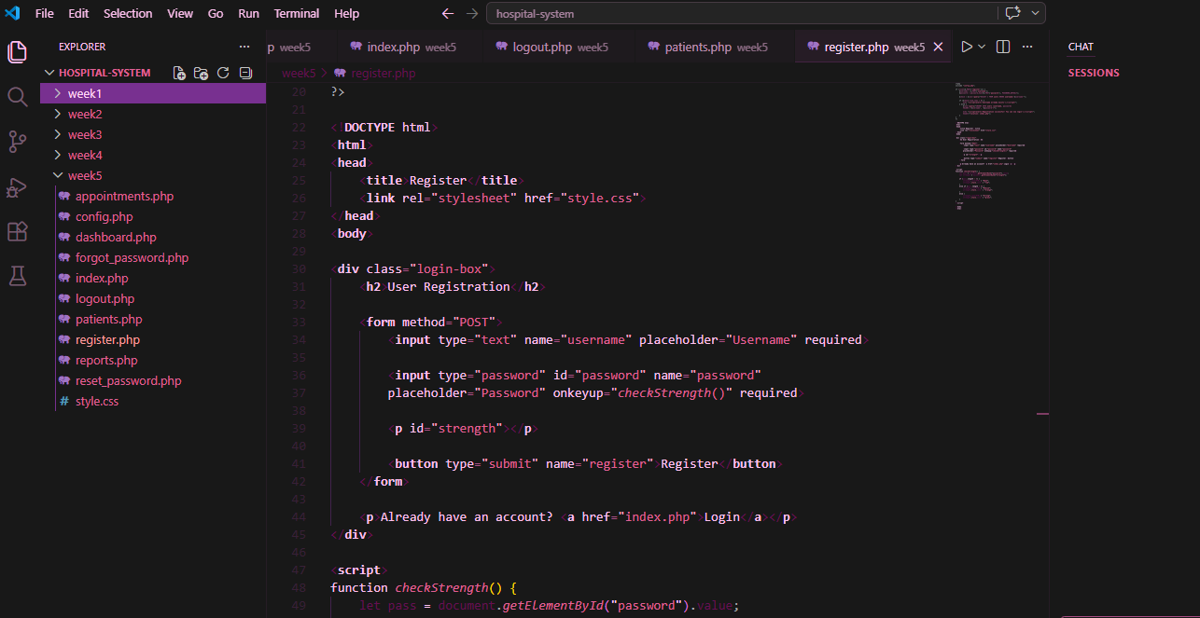
Fig2 shows the screenshot of the register form validation

PHP processing screenshots
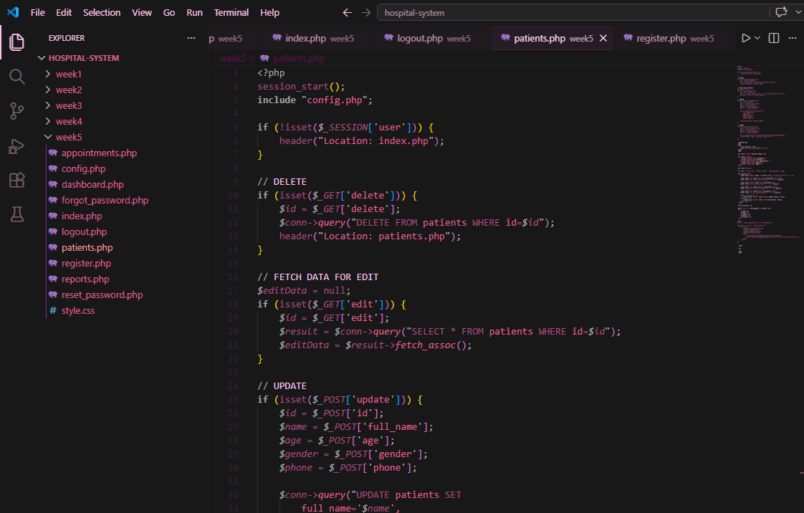
Fig3 shows the screenshot of PHP processing in the patients.php page

Folder structure screenshots
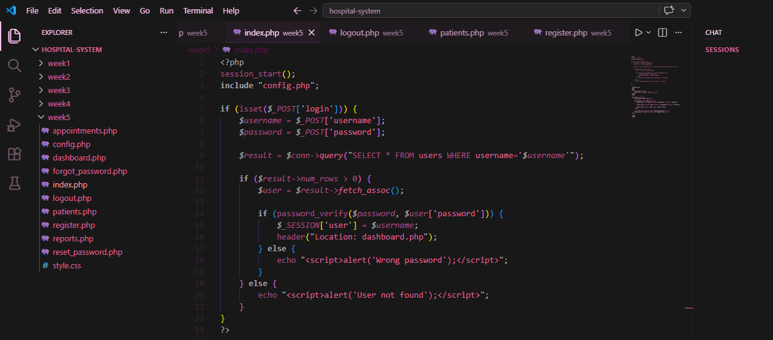
Fig4 shows the screenshot of the structures of how the folders are arranged

Database connection screenshots
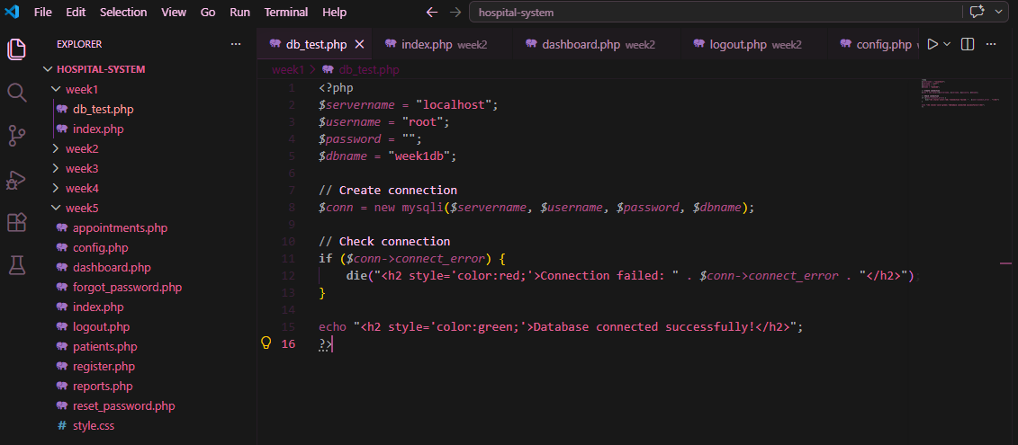
Fig.5 shows the database integration process and how it occurs in the backend side

GitHub updates
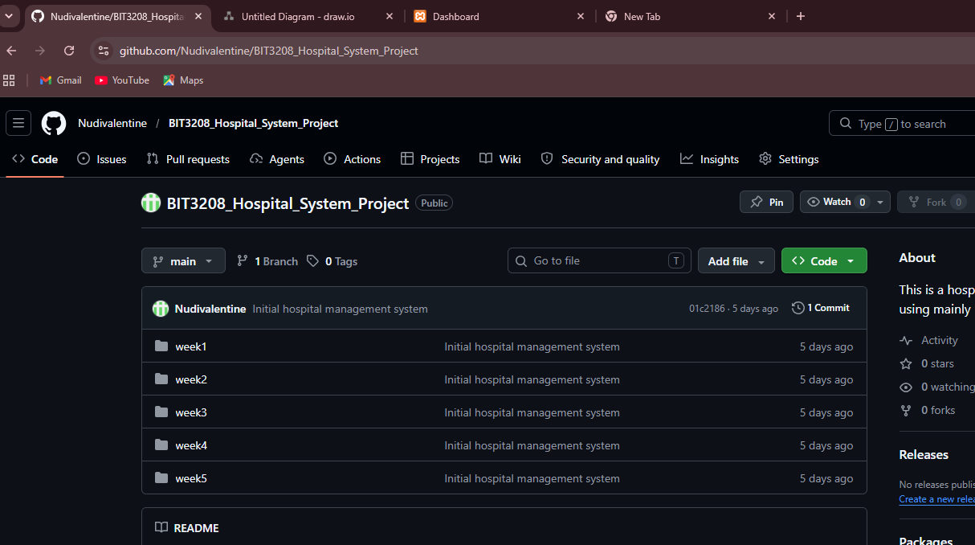
Fig6 shows the Github update process in the github page

Student Reflection
This week helped me understand what happens behind the scenes when a user logs into a system. I learned how information entered in a form is sent to the server, processed by PHP, and stored or checked against the database. The validation features helped prevent empty or incorrect input before submission. I also gained experience using sessions to keep users logged in and organizing project files into a clear folder structure. Using HTML, CSS, JavaScript, PHP, MySQL, XAMPP, and GitHub showed me how frontend and backend technologies work together in a real hospital management system.

Week 5

Database screenshots
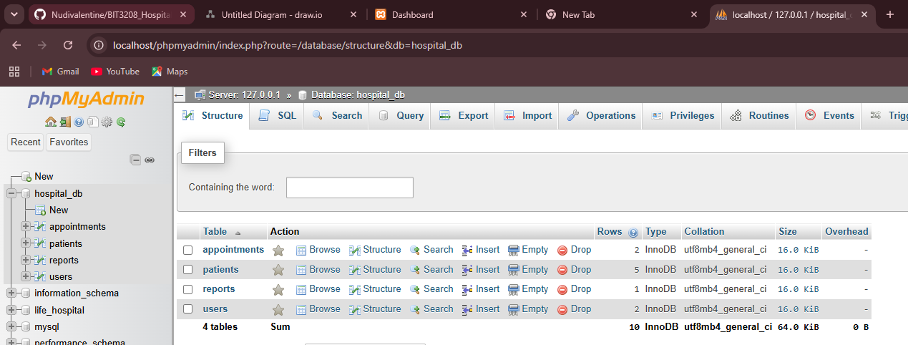
Fig1 shows the screenshot of the database sections in the phpmyadamin

CRUD operation screenshots
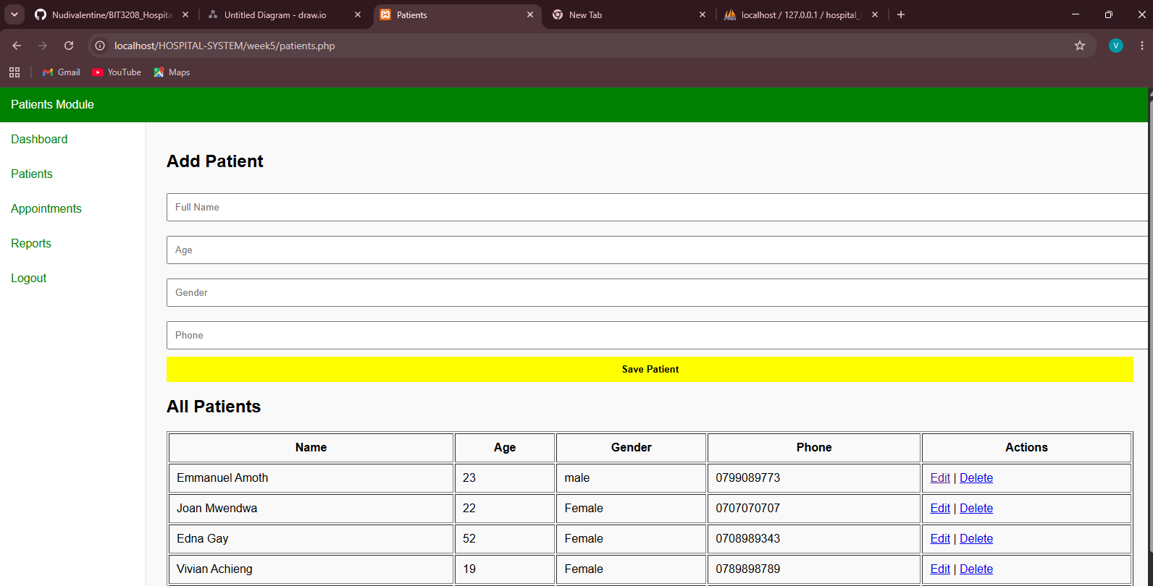
Fig2 shows the operation of CRUD. The user can easily create, read update and delete

Login database integration screenshots
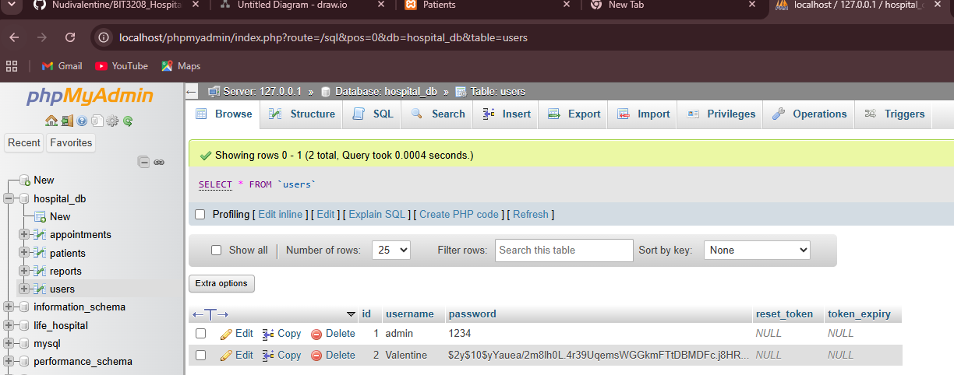
Fig3. Shows the login database intergration screenshot

SQL query screenshots
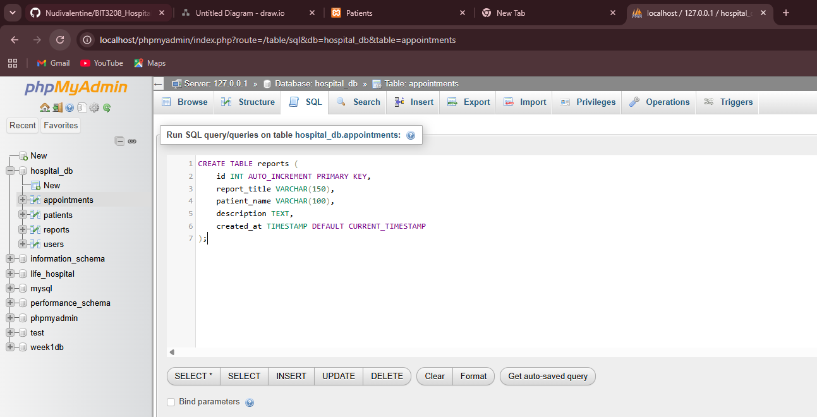
Fig 4. Shows the screenshot of an SQL command that enables automatic creation of reports table in MySQL

GitHub updates

Fig5 shows the Github update process in the github page

Student Reflection
This week helped me understand how databases are used to store and manage information in a real system. I learned how to create database tables and perform CRUD operations (Create, Read, Update, and Delete) using PHP and MySQL. Integrating the login system with the database showed me how user credentials can be verified securely. I also learned how to retrieve and display dynamic data such as patients, appointments, and reports instead of using static content. Through this process, I gained a better understanding of how the frontend, backend, and database work together to build a functional database-driven hospital management system.

Week 6
Database Integration and CRUD Operations

Database Intergration screenshots
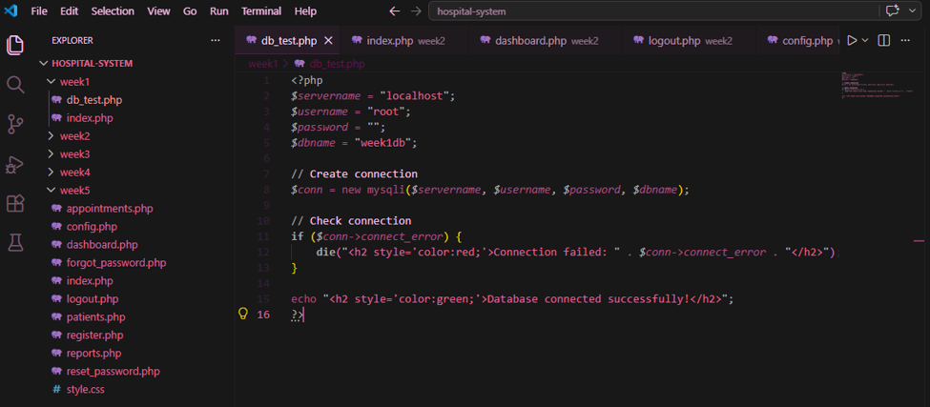
Fig.1 shows the database integration process and how it occurs in the backend side

CRUD operation screenshots

Fig2 shows the operation of CRUD. The user can easily create, read update and delete

Week 7:

User Authentication screenshots

Fig1 shows the user authentication page which asks for the username and password after a user is registered.

Password Hashing screenshots
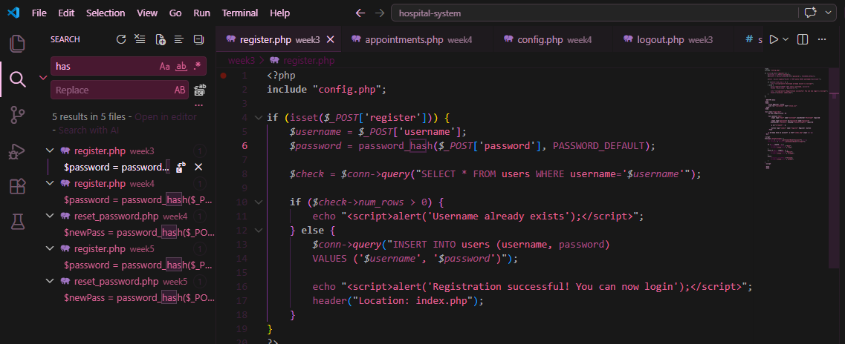
Fig.2 shows the password hashing section which converts passwords into unreadable formats before storing them in a database.

Week 8:Responsive Web Design and Mobile-First Development
Desktop view: displays multiple products per row
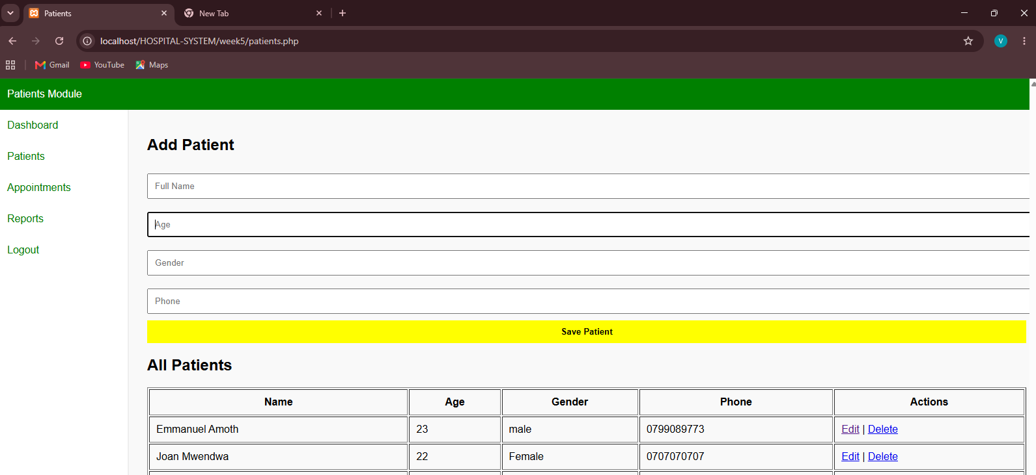
Fig1 shows the desktop display screenshot which proves that it can be openned on a desktop without any issues
Tablet view: displays fewer products.
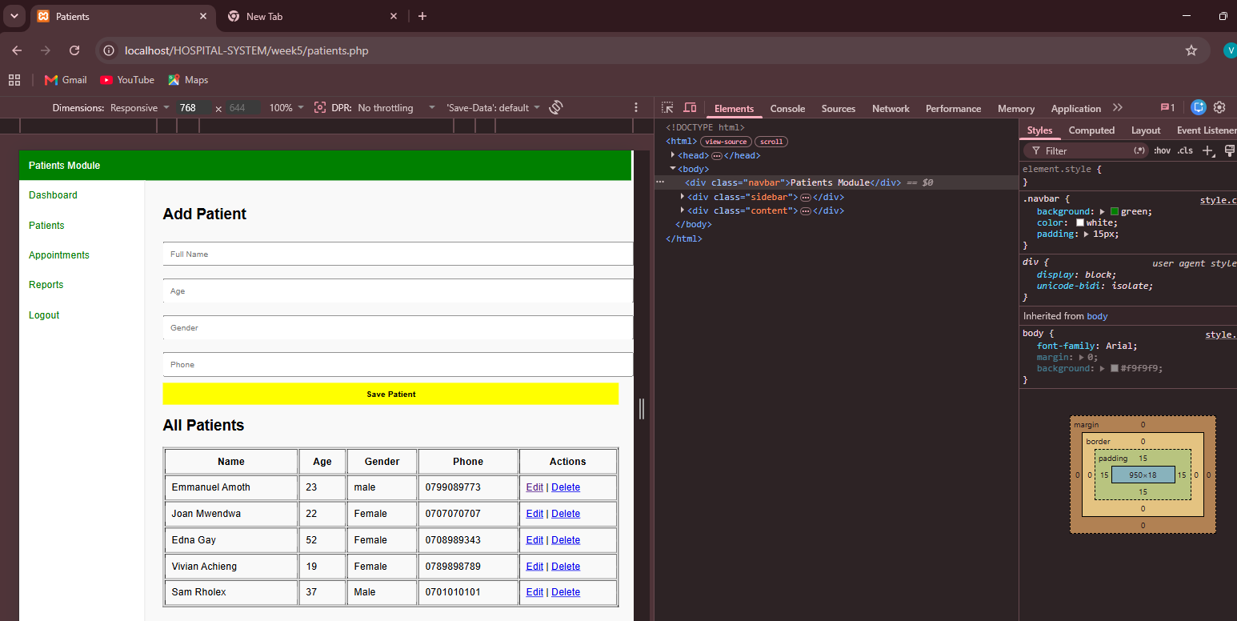
Fig2 shows the tablet display screenshot which proves that it can be openned on a tablet without any issues

Mobile view: displays one product per row.
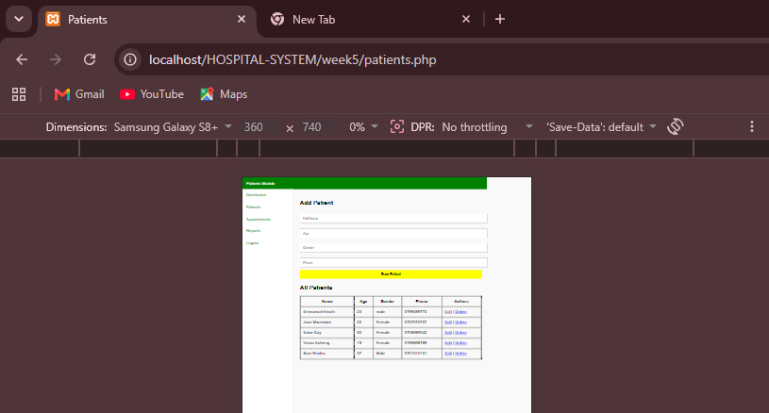
Fig3 shows the tablet display screenshot which proves that it can be openned on a tablet without any issues

